UPWARD CAMERA LIGHT-RING POWER CABLE

- PARTS:

QUANTITY: PART #: NOMENCLATURE: LENGTH:

1 PER CABLE (1 PER MACHINE) 17585-1 HOUSING, 2-PIN, MOLEX N/A

2 PER CABLE (2 PER MACHINE) 18729- TERMINAL, CRIMP, GOLDPLATE N/A

1 PER CABLE (1 PER MACHINE) 17027- CONNECTOR, 3 SKT, FEMALE N/A

2 PER CABLE (2 PER MACHINE) 17023- SOCKET, CONNECTOR N/A

1 PER CABLE (1 PER MACHINE) 19107- WIRE, ORANGE, 22 AWG 42 INCHES

1 PER CABLE (1 PER MACHINE) 19105- WIRE, BLUE, 22 AWG 42 INCHES

1 PER CABLE (1 PER MACHINE) 46776- SLEEVING, ¼” BLACK 41 INCHES

- 2-PIN HOUSING ASSEMBLY:

- STRIP 1/8 INCH OF INSULATION FROM ONE END OF THE ORANGE AND BLUE WIRES.

- CRIMP TWO TERMINALS (18729-) ONTO THE WIRE ENDS, ACCORDING TO DIAGRAM 1.

- INSERT THE CRIMPED PINS INTO THE HOUSING, ACCORDING TO DIAGRAM 2.

NOTE 1
IT IS CRITICAL THAT THE CRIMPED WIRES ARE INSERTED INTO THE HOUSING IN THE ORDER OF COLOR SPECIFIED. ANY VARIATION WILL CAUSE LIGHT EMISSION FAILURE, AND MAY CAUSE DAMAGE TO CIRCUITRY.

- 3-SOCKET FEMALE CONNECTOR ASSEMBLY:

- SLIDE THE SLEEVING ONTO THE ORANGE AND BLUE WIRE PAIR.

B. STRIP 1/8 INCH OF INSULATION FROM ONE END OF THE ORANGE AND BLUE WIRES.

C. CRIMP TWO SOCKETS (17023-) ONTO THE WIRE ENDS, ACCORDING TO DIAGRAM 3

- INSERT THE CRIMPED SOCKETS INTO THE CONNECTOR, ACCORDING TO DIAGRAM 4.

NOTE 1
IT IS CRITICAL THAT THE CRIMPED WIRES ARE INSERTED INTO THE HOUSING IN THE ORDER OF COLOR SPECIFIED. ANY VARIATION WILL CAUSE LIGHT EMISSION FAILURE, AND MAY CAUSE DAMAGE TO CIRCUITRY.

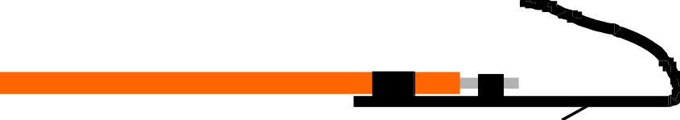

DIAGRAM 1



DIAGRAM 2



DIAGRAM 3

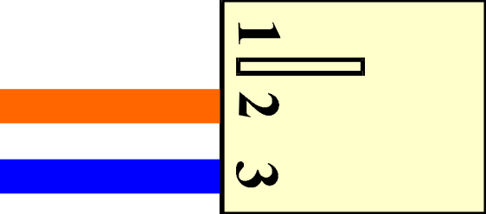

DIAGRAM 4

